A

Project Report on

“Voice Controlled Robot”

Submitted to

Electronics Department

DKTE’s Textile and Engineering Institute, Ichalkaranji



Submitted by

Name Signature

1. Jui Deepak Paranjape. (17UEL11066XX) ……………….
2. Afrin Husenshaha Momin. (17UEL41059XX) ……………….

Under the Guidance of

Mr. V.B.Kumbhar

# 

# Acknowledgement

With the sense of regard and gratitude to our project. We would like to thank our guide **Prof. Mr. V. B. Kumbhar** for giving proper direction to our project, interest and constructive suggestions during study course. We would also like to thank Director **Prof.** **Dr. P. V. Kadole** for providing excel to our life.

We would also like to thank our H.O.D **Prof.** **Dr. Mrs. L. S. Admuthe**. We are very Thankful to all those who help us directly and indirectly to carry out this project.

Thanking You!

Date: 05/10/2018

Place:Ichalkaranji.

**Contents Page no.**

1. Introduction………………………………………………. 04
2. Components Required……………………………………. 05
3. Block diagram ……………………………………………. 12
4. Circuit Diagram………………………………………….. 13
5. Working…………………………………………………….. 14
6. Advantages………………………………………………. 19
7. Applications………………………………………………… 20
8. Conclusion………………………………………………… 21
9. References ……………………………………………… 21

# Introduction

This project Voice Controlled Robotic Vehicle helps to control robot through voice commands received via android application. The integration of control unit with Bluetooth device is done to capture and read the voice commands. The robotic vehicle then operates as per the command received via android application. For this 8051 microcontroller is integrated in the system which makes it possible to operate the vehicle via android application.  
The controlling device may be any android based Smartphone/tab etc having an android OS. The android controlling system provides a good interactive GUI that makes it easy for the user to control the vehicle. The transmitter uses an android application required for transmitting the data.  
The receiver end reads these commands and interprets them into controlling the robotic vehicle.  
The android device sends commands to move the vehicle in forward, backward, right and left directions.  
 After receiving the commands, the microcontroller then operates the motors I order to move the vehicle in four directions. The communication between android device and receiver is sent as serial communication data. The microcontroller program is designed to move the motor through a motor driver IC as per the commands sent by android device.

**Components Required**

1. Android system  
  
2. Arduino Uno  
  
3. 2x L293d motor controller circuit  
  
4. 4x motors and wheels  
  
5. HC SR04 ultrasonic sensor  
  
6. 9g servo  
  
7. Batteries  
  
8. HC 05 Bluetooth Module

**1.Arduino Uno**:

The **Arduino UNO R3** is frequently used[**microcontroller board**](https://www.elprocus.com/avr-atmega8-microcontroller-architecture-applications/) in the family of an Arduino. This is the latest third version of an Arduino board and released in the year 2011. The main advantage of this board is if we make a mistake we can change the microcontroller on the board. The main features of this board mainly include, it is available in DIP (dual-inline-package), detachable and ATmega328 microcontroller. The programming of this board can easily be loaded by using an Arduino computer program. This board has huge support from the Arduino community, which will make a very simple way to start working in embedded electronics, and many more applications.

**What is Arduino Uno ?**

Arduino Uno R3 is one kind of ATmega328P based microcontroller board. It includes the whole thing required to hold up the microcontroller; just attach it to a PC with the help of a USB cable, and give the supply using AC-DC adapter or a battery to get started. The term Uno means “one” in the language of “Italian” and was selected for marking the release of Arduino’s IDE 1.0 software. The R3 Arduino Uno is the 3rd as well as most recent modification of the Arduino Uno. Arduino board and IDE software are the reference versions of Arduino and currently progressed to new releases. The Uno-board is the primary in a sequence of USB-[**Arduino boards**](https://www.elprocus.com/different-types-of-arduino-boards/), & the reference model designed for the Arduino platform.

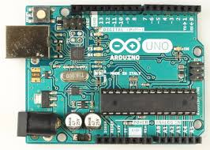

**Arduino Uno Specifications**

The**Arduino Uno board** includes the following specifications.

* It is an ATmega328P based Microcontroller
* The Operating Voltage of the Arduino is 5V
* The recommended input voltage ranges from 7V to 12V
* The i/p voltage (limit) is 6V to 20V
* Digital input and output pins-14
* Digital input & output pins (PWM)-6
* Analog i/p pins are 6
* DC Current for each I/O Pin is 20 mA
* DC Current used for 3.3V Pin is 50 mA
* Flash Memory -32 KB, and 0.5 KB memory is used by the boot loader
* SRAM is 2 KB
* EEPROM is 1 KB
* The speed of the CLK is 16 MHz
* In Built LED
* Length and width of the Arduino are 68.6 mm X 53.4 mm
* The weight of the Arduino board is 25 g

**2.Motor driver (L293D)**

L293D is a typical motor driver or motor driver IC which allows DC motor to driver on either direction L293D is a 16 pin IC which can control a set of two DC motors simultaneously in any direction

It works on the concept of H-bridge. H-bridge is a circuit which allows the voltage to be flown in either direction. As you know voltage need to change its direction for being able to rotate the motor in clockwise or anticlockwise direction, Hence H-bridge IC are ideal for driving a DC motor.In a single L293D chip there are two h-Bridge circuit inside the IC which can rotate two dc motor independently. Due its size it is very much used in robotic application for controlling DC motors. Given below is the pin diagram of a L293D motor controller. There are two Enable pins on l293d. Pin 1 and pin 9, for being able to drive the motor, the pin 1 and 9 need to be high. For driving the motor with left H-bridge you need to enable pin 1 to high. And for right H-Bridge you need to make the pin 9 to high. If anyone of the either pin1 or pin9 goes low then the motor in the corresponding section will suspend working. It’s like a switch.

**Working of L293D**

There are 4 input pins for l293d, pin 2,7 on the left and pin 15 ,10 on the right as shown on the pin diagram. Left input pins will regulate the rotation of motor connected across left side and right input for motor on the right hand side. The motors are rotated on the basis of the inputs provided across the input pins as LOGIC 0 or LOGIC 1.

In simple you need to provide Logic 0 or 1 across the input pins for rotating the motor.

**L293D Logic Table.**

Lets consider a Motor connected on left side output pins (pin 3,6). For rotating the motor in clockwise direction the input pins has to be provided with Logic 1 and Logic 0.

**• Pin 2 = Logic 1**and **Pin 7 = Logic 0**| Clockwise Direction **• Pin 2 = Logic 0**and**Pin 7 = Logic 1**| Anticlockwise Direction **• Pin 2 = Logic 0**and**Pin 7 = Logic 0**| Idle [No rotation] [Hi-Impedance state] **• Pin 2 = Logic 1**and**Pin 7 = Logic 1**| Idle [No rotation]

In a very similar way the motor can also operate across input pin 15,10 for motor on the right hand side.

**Circuit Diagram For l293d motor driver IC controller.**

[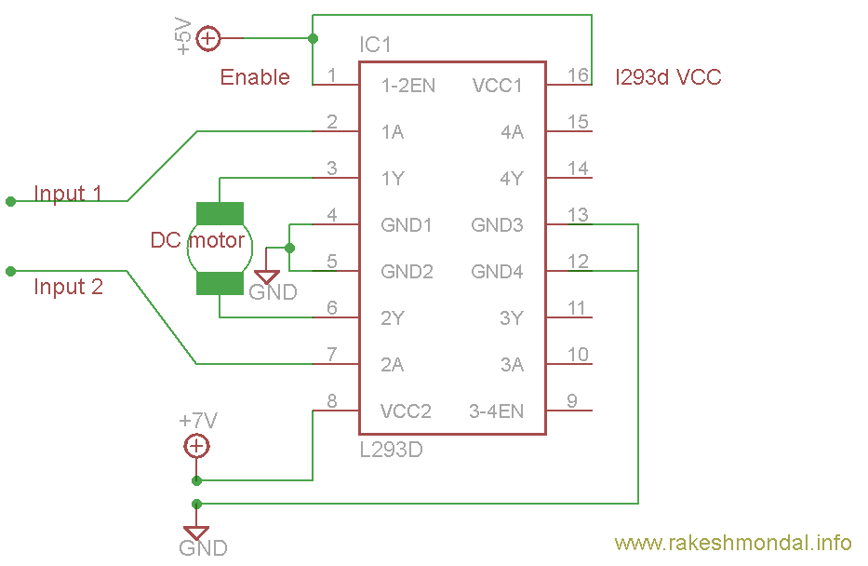](https://www.rakeshmondal.info/pik/l293d%20cirucit%20diagram.png)

**Voltage Specification**

VCC is the voltage that it needs for its own internal operation 5v; L293D will not use this voltage for driving the motor. For driving the motors it has a separate provision to provide motor supply VSS (V supply).  L293d will use this to drive the motor. It means if you want to operate a motor at 9V then you need to provide a Supply of 9V across VSS Motor supply.

The maximum voltage for VSS motor supply is 36V. It can supply a max current of 600mA per channel.Since it can drive motors Up to 36v hence you can drive pretty big motors with this l293d.

VCC pin 16 is the voltage for its own internal Operation. The maximum voltage ranges from 5v and upto 36v.

#### **HC-05 Bluetooth Module:**

#### HC-05 Bluetooth Module

The HC-05 Bluetooth Module is responsible for enabling Bluetooth Communication between Arduino and Android Phone.

The **HC-05** has two operating modes, one is the Data mode in which it can send and receive data from other Bluetooth devices and the other is the AT Command mode where the default device settings can be changed. We can operate the device in either of these two modes by using the key pin as explained in the pin description.

It is very easy to pair the HC-05 module with microcontrollers because it operates using the Serial Port Protocol (SPP). Simply power the module with +5V and connect the Rx pin of the module to the Tx of MCU and Tx pin of module to Rx of MCU as shown in the figure below

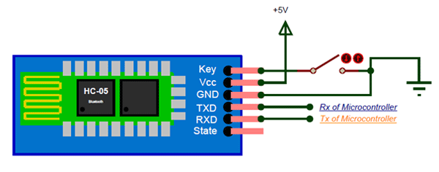

During power up the key pin can be grounded to enter into Command mode, if left free it will by default enter into the data mode. As soon as the module is powered you should be able to discover the Bluetooth device as “HC-05” then connect with it using the default password 1234 and start communicating with it. The name password and other default parameters can be changed by entering into the

1. **Servo motor SG90:**

Typically, servo motors are a combination of four things: a conventional DC motor, a set of gearings, a potentiometer, and a control circuit. Among these four things, the potentiometer acts as a position sensor. As a result, servo motors can be controlled very precisely. In particular, a command can be sent to the servo so that the servo’s shaft rotates to a specific position. However, the disadvantage of these servos is that the rotation range is limited (e.g. between 0 and 180 degrees). Nonetheless, servo motors are very useful if a project requires a motor with a precise control and awareness of its current position.

[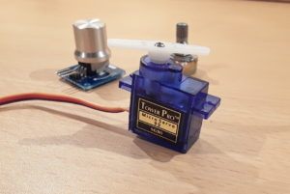](http://www.mschoeffler.de/wp-content/uploads/2017/09/sg90.jpg)

**The SG90 micro servo motor**

In the background is a rotary angle sensor module and a potentiometer. Both can be used to control the servo motor.

The SG90 is such a servo motor that can rotate approximately 180°. Moreover, is is very small and lightweight (Weight: 9g; Dimension: 22.2 x 11.8 x 31 mm). In this tutorial, it is shown how to control the SG90 servo motor. In order to control the motor, a so-called rotary angle sensor module is used. This module is nothing more than a conventional potentiometer combined with a knob. Therefore, it can be simply replaced by almost any potentiometer, since it is used here only for convenience reasons.

### **HC-SR04 Ultrasonic Sensor**

As shown above the **HC-SR04 Ultrasonic (US) sensor** is a 4 pin module, whose pin names are Vcc, Trigger, Echo and Ground respectively. This sensor is a very popular sensor used in many applications where measuring distance or sensing objects are required. The module has two eyes like projects in the front which forms the Ultrasonic transmitter and Receiver. The sensor works with the simple high school formula that

**Distance = Speed × Time**

The Ultrasonic transmitter transmits an ultrasonic wave, this wave travels in air and when it gets objected by any material it gets reflected back toward the sensor this reflected wave is observed by the Ultrasonic receiver module as shown in the picture below

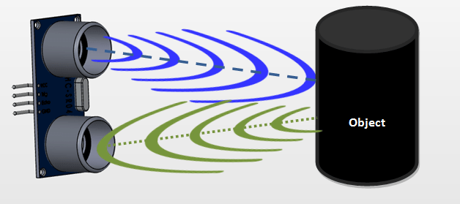

Now, to calculate the distance using the above formulae, we should know the Speed and time. Since we are using the Ultrasonic wave we know the universal speed of US wave at room conditions which is 330m/s. The circuitry inbuilt on the module will calculate the time taken for the US wave to come back and turns on the echo pin high for that same particular amount of time, this way we can also know the time taken. Now simply calculate the distance using a microcontroller or microprocessor.

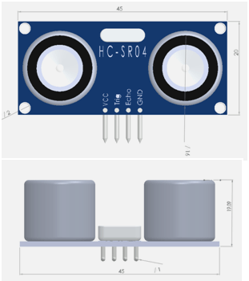

**2D model of the component**

**Circuit diagram:**

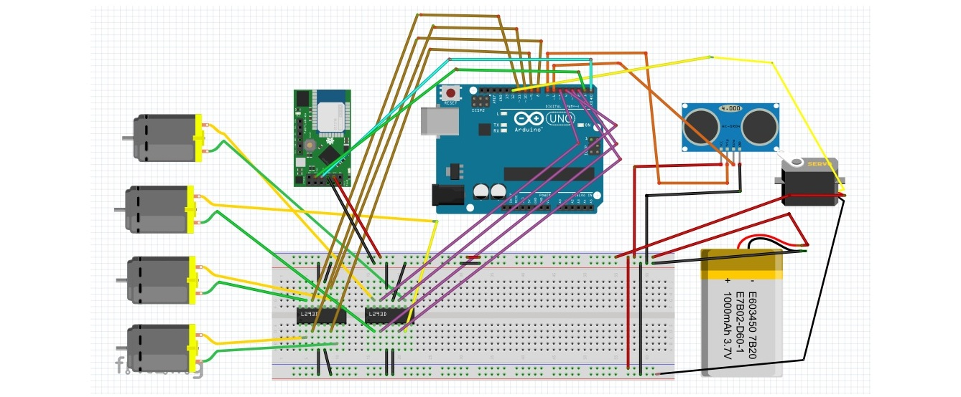

**Working:**

Assemble the robot, make the necessary connections and upload the code to Arduino. If you understood the HC-05 Bluetooth Module tutorial, then understanding the Bluetooth Controlled Robot project is very easy.

First, in the Android App, we have used 5 keys as Forward, Reverse, Left, Right and Stop. The corresponding data associated with each key is as follows:

* Forward – 1
* Reverse – 2
* Left – 3
* Right – 4
* Stop – 5

When a key is pressed, the corresponding data is transmitted to the Bluetooth Module from the Phone over Bluetooth Communication.

In the Arduino code, the Arduino UNO receives any of this data from the Bluetooth Module (as per the key pressed) and performs a simple switch case operation, where each case associated with appropriate instructions to the Motor Driver Input Pins.

For example, if ‘Forward’ key is pressed in the Android Phone, then ‘1’ is transmitted. Arduino will then make IN1 and IN3 as HIGH and IN2 and IN4 as LOW to achieve a forward motion.

Similarly, other keys correspond to appropriate setting of IN1 – IN4 pins.

#### **Block Diagram:**

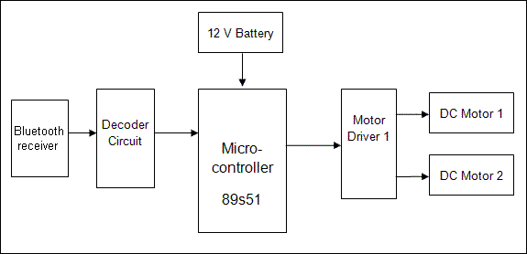

**Advantages:**

1. The robot is small in size so can be used for spying.

2. With few additions and modifications, this robot can be

used in the borders for detecting and disposing hidden land mines.

3. The robot can be used for reconnaissance or surveillance.

### **Applications:**

1.Low range Mobile Surveillance Devices

2.Military Applications (no human intervention)

3.Assistive devices (like wheelchairs)

4.Home automation

**Future Development:**

1. We can interface sensors to this robot so that it can monitor some parameters.

2. We can add wireless camera to this robot.

**Conclusion:**

The Arduino is an open source device that has been the brain for numerous projects. The Arduino has everything that is required by the user which includes its inbuilt converter, i/o pins etc. With the combination of Arduino, and the Bluetooth Shield we can control over many other things, like home Lightings, air conditioner and many more through our cell phones. The Arduino can also contribute at large for the Smart Home system. By doing this Project we found out a lot about the Arduino, and how it has made us easier to convert digital signals into physical movements. One more advantage of Arduino is that once a program is burned we don‘t need to worry about the program getting erased as long as it is not RESET. Arduino has also over all other microcontroller because of its efficiency and user friendly property.

**References Books:**

1) Introduction to Arduino, A piece of cake!, by Alan G. Smith, September 30, 2011

2) 30 Arduino Projects for the Evil Genius™ Simon Monk, McGraw-Hill Companies Inc

**References on the web:**

1) https://www.instructables.com/

2) https://circuitdigest.com/

3) https://nptel.ac.in/